15. Develop a system using UML for Blood Bank Registration System.

Use case diagram:

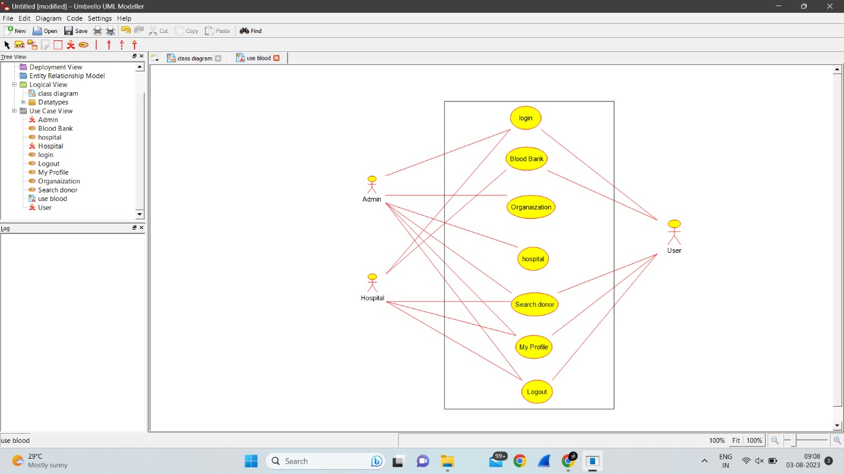

Activity diagram:

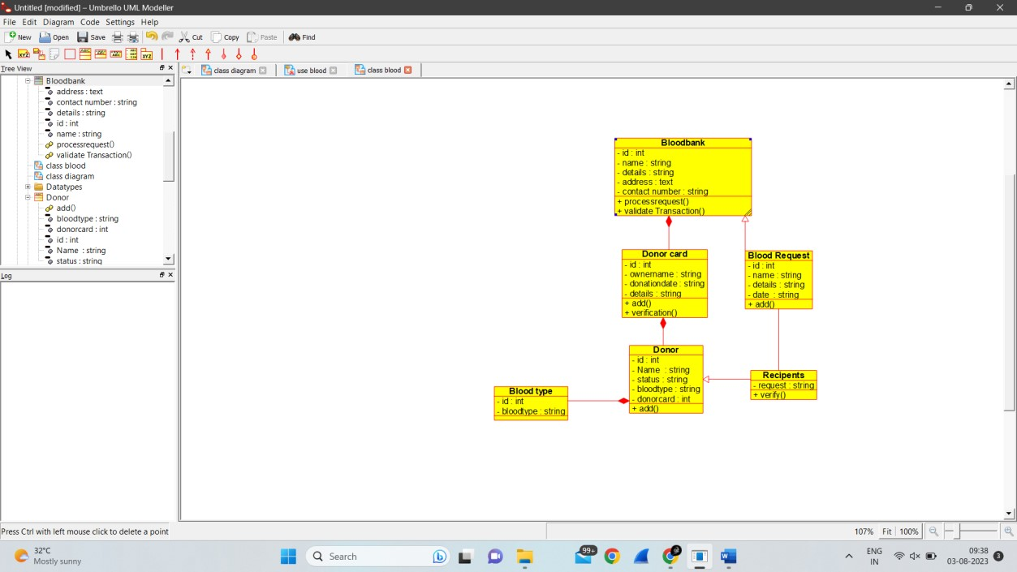

State diagram:

